BAND PERFORMANCE CONTRACT (PRIVATE EVENTS)

This contract is made on this day of ____________ (today’s date) between
______________ (the "Operator") and Jahzilla LLC (the "Band") for the hiring of the Band as an independent contractor(s) to perform musical entertainment.

It is agreed as follows:

Date & Time. The parties agree that the date of show will occur on _________________ (date of performance) with a performance time staring at _________ (start time) and ending at___________ (end time).
Location. The location of the show will take place at: _________________________________________________________________
Description of Show. Show will be a musical performance by the Band.
Attire. (choose one) Formal, Business-Casual, Tropical, Black-Professional, or Custom__________
Extra microphone. (no extra charge) Will an extra microphone be needed for a speech? Y/N
Lighting. (no extra charge) Will you need uplighting for the Band? Y/N If so, what color:____________
Valet. If applicable, will the Band be compensated for valet parking? Y/N
Meal. Will there be a meal provided for the Band? Y/N
Payment. Compensation for the Show is ___________. If paying by check, please make the check out to Jahzilla LLC.
Deposit. A deposit of __________ is required upon the signing of this contract. All remaining payments are due by the end of the date of performance.
Cancellation. In the event of a cancellation by the Operator, their deposit will be non refundable. In the rare event of a cancellation by the Band due to a medical emergency, the Operator’s deposit Fee as well as any other money paid to the Band by Operator will be returned within thirty (30) days.
Force Majeure. In the event Show cannot reasonably be put on because of unpredictable occurrences such as an act of nature, the deposit will be returned within thirty (30) days and no additional money is due the Band.
Parking. Operator will secure sufficient parking for Band's vehicles for a minimum period of 1 hour prior to the show to unload equipment and 1 hour after the show.
Sound Systems Check. A sound check conducted by the Band is required 15 minutes or more prior to the Show.
Indemnification. Operator indemnifies and holds Band harmless for claims of property damage or bodily injury solely caused by Operator or Operator’s Guests at the Show.
Severability. If any portion of Agreement is in conflict with any applicable law, such portion will become inoperative, but all other portions of Agreement will remain in force.
Interpretation. Agreement will be interpreted according to the laws of the State of Florida

The below-signed Band Representative warrants s/he has authority to enforceably sign this agreement for Band in its entirety. The below signed Operator's Representative warrants s/he has authority to bind Operator and Venue (above).

Signature of Band Representative:

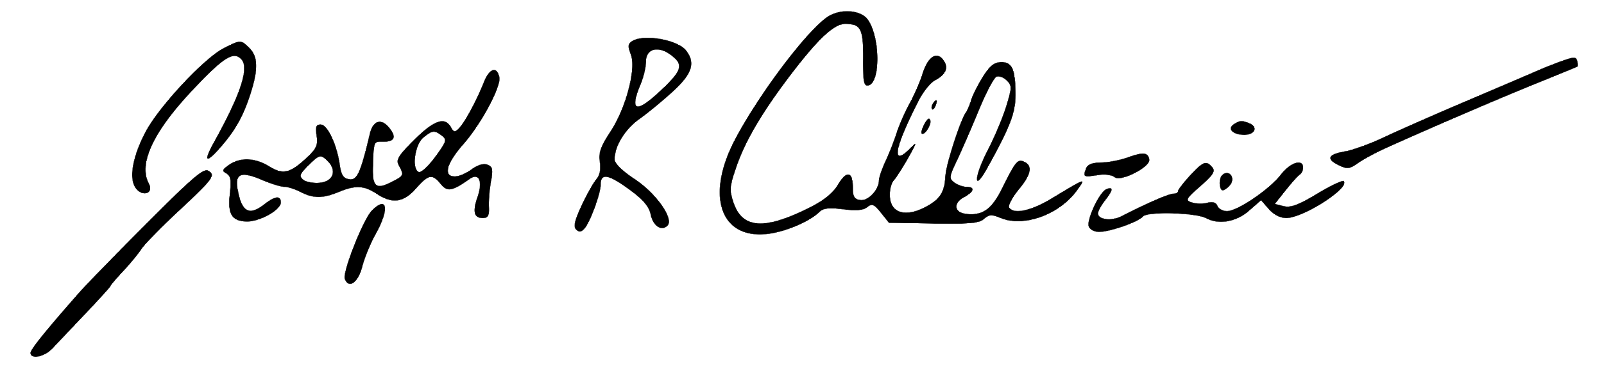 _________________________________________________________________
Joseph R Calderaio Date

Operator's Representative Signature:

_________________________________________________________________
Name Date

